**Fall 2019**

**CSE-5321-002 - Software Testing**

**Homework Assignment 1**

|  |  |
| --- | --- |
| **Name** | **UTA ID** |
| Goutami Padmanabhan | 1001669338 |

Please find the worksheet I used for calculations (HW_1_answers.xlsx), attached to the zip file I submitted.

**Question 1**

|  |  |  |  |  |
| --- | --- | --- | --- | --- |
| **Test Case Number** | **Inputs** | **Expected Outputs** | | |
| **Number of shares** | **Portfolio Amount** | **Customer Status** | **Brokerage Fees** |
| 1 | 0 | $0.00 | Ordinary | $0.00 |
| 2 | 100 | $14,110.60 | Ordinary | $0.00 |
| 3 | 101 | $14,299.78 | Ordinary | $0.00 |
| 4 | 350 | $49,553.70 | Ordinary | $0.00 |
| 5 | 351 | $49,959.35 | Ordinary | $75.00 |
| 6 | 500 | $71,199.00 | Ordinary | $75.00 |
| 7 | 501 | $71,530.93 | Ordinary | $75.00 |
| 8 | 750 | $107,119.50 | Ordinary | $75.00 |
| 9 | 751 | $107,630.42 | Ordinary | $75.00 |
| 10 | 1000 | $143,341.00 | Ordinary | $75.00 |
| 11 | 1001 | $144,731.66 | Prime | $75.00 |
| 12 | 5000 | $723,235.00 | Prime | $75.00 |

**Question 2**

|  |  |  |  |
| --- | --- | --- | --- |
| **Test Case Number** | **Inputs** | | **Expected Outputs** |
| **Time** | **Type Day** | **Volume/hr** |
| 1 | 12:00:00AM | Weekday | 12 |
| 2 | 6:00:00AM | Weekday | 12 |
| 3 | 6:00:01AM | Weekday | 123 |
| 4 | 8:00:00AM | Weekday | 123 |
| 5 | 8:00:01AM | Weekday | 12 |
| 6 | 1:59:59PM | Weekday | 12 |
| 7 | 2:00:00PM | Weekday | 123 |
| 8 | 7:00:00PM | Weekday | 123 |
| 9 | 7:00:01PM | Weekday | 12 |
| 10 | 11:59:59PM | Weekday | 12 |
| 11 | 12:00:00AM | Weekend | 7 |
| 12 | 6:00:00AM | Weekend | 7 |
| 13 | 6:00:01AM | Weekend | 73 |
| 14 | 8:00:00AM | Weekend | 73 |
| 15 | 8:00:01AM | Weekend | 7 |
| 16 | 1:59:59PM | Weekend | 7 |
| 17 | 2:00:00PM | Weekend | 73 |
| 18 | 7:00:00PM | Weekend | 73 |
| 19 | 7:00:01PM | Weekend | 7 |
| 20 | 11:59:59PM | Weekend | 7 |
| 21 | 12:00:00AM | Holiday | 21 |
| 22 | 6:00:00AM | Holiday | 21 |
| 23 | 6:00:01AM | Holiday | 219 |
| 24 | 8:00:00AM | Holiday | 219 |
| 25 | 8:00:01AM | Holiday | 21 |
| 26 | 1:59:59PM | Holiday | 21 |
| 27 | 2:00:00PM | Holiday | 219 |
| 28 | 7:00:00PM | Holiday | 219 |
| 29 | 7:00:01PM | Holiday | 21 |
| 30 | 11:59:59PM | Holiday | 21 |

**Question 3**

|  |  |  |  |  |  |  |
| --- | --- | --- | --- | --- | --- | --- |
| **Test Case Number** | **Inputs** | **Expected Outputs** | | | | |
| **Fuel Level (gallons)** | **Bell** | **Buzzer** | **Red Light** | **Yellow Light** | **Green Light** |
| 1 | 25.0 | OFF | OFF | OFF | OFF | OFF |
| 2 | 20.1 | OFF | OFF | OFF | OFf | OFF |
| 3 | 20.0 | OFF | OFF | ON | OFF | OFF |
| 4 | 15.0 | OFF | OFF | ON | OFF | OFF |
| 5 | 14.9 | OFF | OFF | ON | ON | OFF |
| 6 | 12.6 | OFF | OFF | ON | ON | OFF |
| 7 | 12.5 | ON | OFF | ON | ON | OFF |
| 8 | 6.3 | ON | OFF | ON | ON | OFF |
| 9 | 6.2 | ON | ON | ON | ON | OFF |
| 10 | 5.6 | ON | ON | ON | ON | OFF |
| 11 | 5.5 | ON | ON | ON | ON | ON |
| 12 | 0.0 | ON | ON | ON | ON | ON |

**Question 4**

|  |  |  |  |  |
| --- | --- | --- | --- | --- |
| **Test Case Number** | **Inputs** | **Expected Outputs** | | |
| **Number of shares** | **Portfolio Amount** | **Customer Status** | **Brokerage Fees** |
| 1 | 0 | $0.00 | Ordinary | $0.00 |
| 2 | 100 | $14,110.60 | Ordinary | $0.00 |
| 3 | 101 | $14,299.78 | Ordinary | $0.00 |
| 4 | 350 | $49,553.70 | Ordinary | $0.00 |
| 5 | 351 | $49,959.35 | Ordinary | $75.00 |
| 6 | 500 | $71,199.00 | Ordinary | $75.00 |
| 7 | 501 | $71,530.93 | Ordinary | $75.00 |
| 8 | 750 | $107,119.50 | Ordinary | $75.00 |
| 9 | 751 | $107,630.42 | Ordinary | $75.00 |
| 10 | 1000 | $143,341.00 | Ordinary | $75.00 |
| 11 | 1001 | $144,731.66 | Ordinary | $75.00 |
| 12 | 1037 | $149,939.49 | Ordinary | $75.00 |
| 13 | 1038 | $150,084.16 | Silver | $75.00 |
| 14 | 1383 | $199,992.55 | Silver | $75.00 |
| 15 | 1384 | $200,137.21 | Gold | $75.00 |
| 16 | 1728 | $249,900.94 | Gold | $75.00 |
| 17 | 1729 | $250,045.60 | Platinum | $75.00 |
| 18 | 5000 | $723,235.00 | Platinum | $75.00 |

**Question 5**

***Question 1: Decision Table***

|  |  |  |  |  |  |  |
| --- | --- | --- | --- | --- | --- | --- |
|  | **Rule 1** | **Rule 2** | **Rule 3** | **Rule 4** | **Rule 5** | **Rule 6** |
| **Conditions** | | | | | | |
| 0 <= Number of Shares <= 100 | Y |  |  |  |  |  |
| 101 <= Number of Shares <= 350 |  | Y |  |  |  |  |
| 351 <= Number of Shares <= 500 |  |  | Y |  |  |  |
| 501 <= Number of Shares <= 750 |  |  |  | Y |  |  |
| 751 <= Number of Shares <= 1000 |  |  |  |  | Y |  |
| 1001 <= Number of Shares <= ∞ |  |  |  |  |  | Y |
| **Actions** | | | | | | |
| Dividend | 0.79% | 1.13% | 1.82% | 2.09% | 2.44% | 3.33% |
| Brokerage Fee | $0.00 | $0.00 | $75.00 | $75.00 | $75.00 | $75.00 |
| Customer Status | Ordinary | Ordinary | Ordinary | Ordinary | Ordinary | Prime |
| **Table implements "first-of" rule** | | | | | | |

***Number of test cases required: 12 test cases***

There are 12 Boundary Values and 6 Rules, so the greater of the two is 12

2 tests*6ECPs = 12 tests

***Does this number agree with the number of tests developed above? Yes or No:*** Yes

This agrees with the number of test cases developed in Question 1.

***Question 2: Decision Table***

|  |  |  |  |  |  |  |  |  |  |  |  |  |  |  |  |
| --- | --- | --- | --- | --- | --- | --- | --- | --- | --- | --- | --- | --- | --- | --- | --- |
|  | **Rule 1** | **Rule 2** | **Rule 3** | **Rule 4** | **Rule 5** | **Rule 6** | **Rule 7** | **Rule 8** | **Rule 9** | **Rule 10** | **Rule 11** | **Rule 12** | **Rule 13** | **Rule 14** | **Rule 15** |
| **Conditions** | | | | | | | | | | | | | | | |
| 12:00:00 AM <= Time <= 6:00:00AM Weekday | Y |  |  |  |  |  |  |  |  |  |  |  |  |  |  |
| 6:00:01AM <= Time <= 8:00:00AM Weekday |  | Y |  |  |  |  |  |  |  |  |  |  |  |  |  |
| 8:00:01AM <= Time <= 1:59:59PM Weekday |  |  | Y |  |  |  |  |  |  |  |  |  |  |  |  |
| 2:00:00PM <= Time <= 7:00:00PM Weekday |  |  |  | Y |  |  |  |  |  |  |  |  |  |  |  |
| 7:00:01PM <= Time <= 11:59:59PM Weekday |  |  |  |  | Y |  |  |  |  |  |  |  |  |  |  |
| 12:00:00 AM <= Time <= 6:00:00AM Weekend |  |  |  |  |  | Y |  |  |  |  |  |  |  |  |  |
| 6:00:01AM <= Time <= 8:00:00AM Weekend |  |  |  |  |  |  | Y |  |  |  |  |  |  |  |  |
| 8:00:01AM <= Time <= 1:59:59PM Weekend |  |  |  |  |  |  |  | Y |  |  |  |  |  |  |  |
| 2:00:00PM <= Time <= 7:00:00PM Weekend |  |  |  |  |  |  |  |  | Y |  |  |  |  |  |  |
| 7:00:01PM <= Time <= 11:59:59PM Weekend |  |  |  |  |  |  |  |  |  | Y |  |  |  |  |  |
| 12:00:00 AM <= Time <= 6:00:00AM Holiday |  |  |  |  |  |  |  |  |  |  | Y |  |  |  |  |
| 6:00:01AM <= Time <= 8:00:00AM Holiday |  |  |  |  |  |  |  |  |  |  |  | Y |  |  |  |
| 8:00:01AM <= Time <= 1:59:59PM Holiday |  |  |  |  |  |  |  |  |  |  |  |  | Y |  |  |
| 2:00:00PM <= Time <= 7:00:00PM Holiday |  |  |  |  |  |  |  |  |  |  |  |  |  | Y |  |
| 7:00:01PM <= Time <= 11:59:59PM Holiday |  |  |  |  |  |  |  |  |  |  |  |  |  |  | Y |
| **Actions** | | | | | | | | | | | | | | | |
| Type - High Volume (H), Low Volume (L) | L | H | L | H | L | L | H | L | H | L | L | H | L | H | L |
| **Table implements "first-of" rule** | | | | | | | | | | | | | | | |

***Number of test cases required: 30 test cases***

There are 30 Boundary Values and 15 Rules, so the greater of the two is 30

2 tests*15ECPs = 30 tests

***Does this number agree with the number of tests developed above? Yes or No:*** Yes

This agrees with the number of test cases developed in Question 2.

***Question 3: Decision Table***

|  |  |  |  |  |  |  |
| --- | --- | --- | --- | --- | --- | --- |
|  | **Rule 1** | **Rule 2** | **Rule 3** | **Rule 4** | **Rule 5** | **Rule 6** |
| **Conditions** | | | | | | |
| 25.0 <= Fuel level (gallons) <= 20.1 | Y |  |  |  |  |  |
| 20.0 <= Fuel level (gallons) <= 15.0 |  | Y |  |  |  |  |
| 14.9 <= Fuel level (gallons) <= 12.6 |  |  | Y |  |  |  |
| 12.5 <= Fuel level (gallons) <= 6.3 |  |  |  | Y |  |  |
| 6.2 <= Fuel level (gallons) <= 5.6 |  |  |  |  | Y |  |
| 5.5 <= Fuel level (gallons) <= 0.0 |  |  |  |  |  | Y |
| **Actions** | | | | | | |
| Alarm = Red Light | OFF | **ON** | **ON** | **ON** | **ON** | **ON** |
| Alarm = Yellow Light | OFF | OFF | **ON** | **ON** | **ON** | **ON** |
| Alarm = Bell | OFF | OFF | OFF | **ON** | **ON** | **ON** |
| Alarm = Buzzer | OFF | OFF | OFF | OFF | **ON** | **ON** |
| Alarm = Green Light | OFF | OFF | OFF | OFF | OFF | **ON** |
| **Table implements "first-of" rule** | | | | | | |

***Number of test cases required: 12 test cases***

There are 12 Boundary Values and 6 Rules, so the greater of the two is 12

2 tests*6ECPs = 12 tests

***Does this number agree with the number of tests developed above? Yes or No:*** Yes

This agrees with the number of test cases developed in Question 3.

**Question 6**

**State Diagram:**

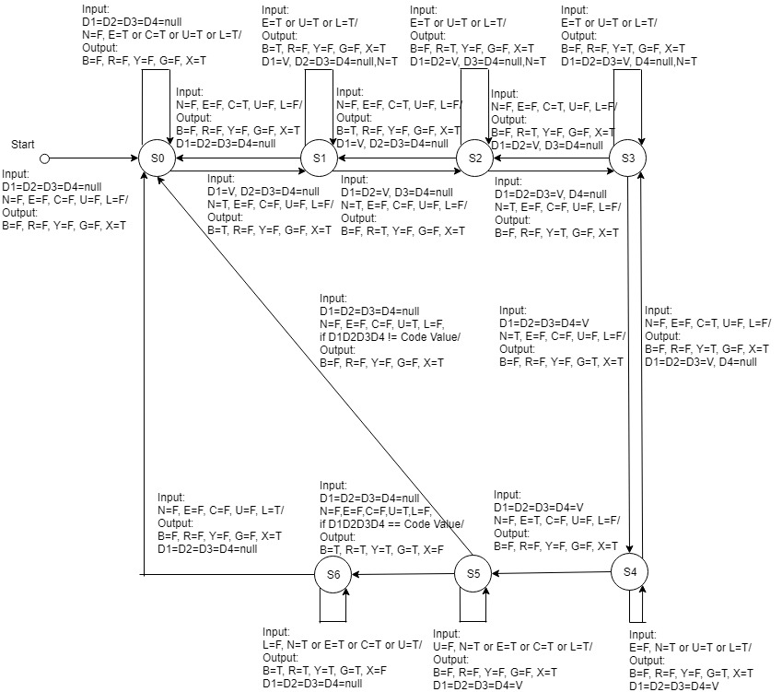

T=True, F = False

S0 to S6 – Transition States

“If D1D2D3D4 == Code Value” means when all 4 concatenated digits D1D2D3D4 are equal to the Code value

“If D1D2D3D4 != Code Value” means when all 4 concatenated digits D1D2D3D4 are not equal to the Code value